PIZZA SALES MySQL QUERIES

Total Revenues:

SELECT SUM(total_price) AS Total_Revenues FROM pizzadb.pizza_sales;

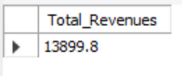

Average Order Value

SELECT SUM(total_price)/COUNT(distinct order_id) AS Avg_Order_Value from pizzadb.pizza_sales;

Total Pizzas Sold

Select Sum(quantity) AS Total_Pizza_Sold from pizzadb.pizza_sales;

Total Orders

Select COUNT(distinct order_id) AS total_orders from pizzadb.pizza_sales;

Average Pizzas Per Order

Select SUM(quantity)/COUNT(distinct order_id) AS Avg_pizzas_per_orders From pizzadb.pizza_sales;

B..Daily Trend for total orders

SELECT DAYNAME(STR_TO_DATE(order_date, '%d-%m-%Y')) AS order_day,

COUNT(DISTINCT order_id) AS Total_orders

FROM pizzadb.pizza_sales

GROUP BY DAYNAME(STR_TO_DATE(order_date, '%d-%m-%Y'));

Houry Trend

Select HOUR(order_time) AS order_hour,

COUNT(distinct order_id) as Total_orders

From pizzadb.pizza_sales

GROUP BY HOUR(order_time)

Order BY HOUR(order_time);

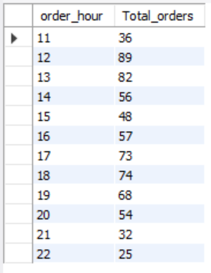

Percentage Trend

Select pizza_category, Round(SUM(total_price),2) AS total_sales,

Round((SUM(total_price)/ (Select SUM(total_price) FROM pizzadb.pizza_sales) *100),2) AS percentage_sales

From pizzadb.pizza_sales

GROUP BY (pizza_category)

ORDER BY Total_sales DESC;

TOTAL PERCENTAGE PIZZA SOLD BY SIZES

Select pizza_size, Round(SUM(total_price),2) AS total_sales,

Round((SUM(total_price)/ (Select SUM(total_price) FROM pizzadb.pizza_sales) *100),2) AS percentage_sales

From pizzadb.pizza_sales

GROUP BY (pizza_size)

ORDER BY pizza_size DESC;

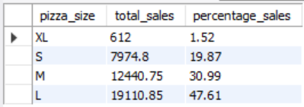

PIZZA BEST SELLERS by total pizza sold

Select pizza_category, sum(quantity) as Total_pizzas_sold

from pizzadb.pizza_sales

group by pizza_category

ORDER BY Total_pizzas_sold DESC;

THE TOP 5 PIZZA BEST SELLERS

Select pizza_name, sum(quantity) as Total_pizzas_sold

from pizzadb.pizza_sales

group by pizza_name

ORDER BY Total_pizzas_sold DESC

LIMIT 5;

